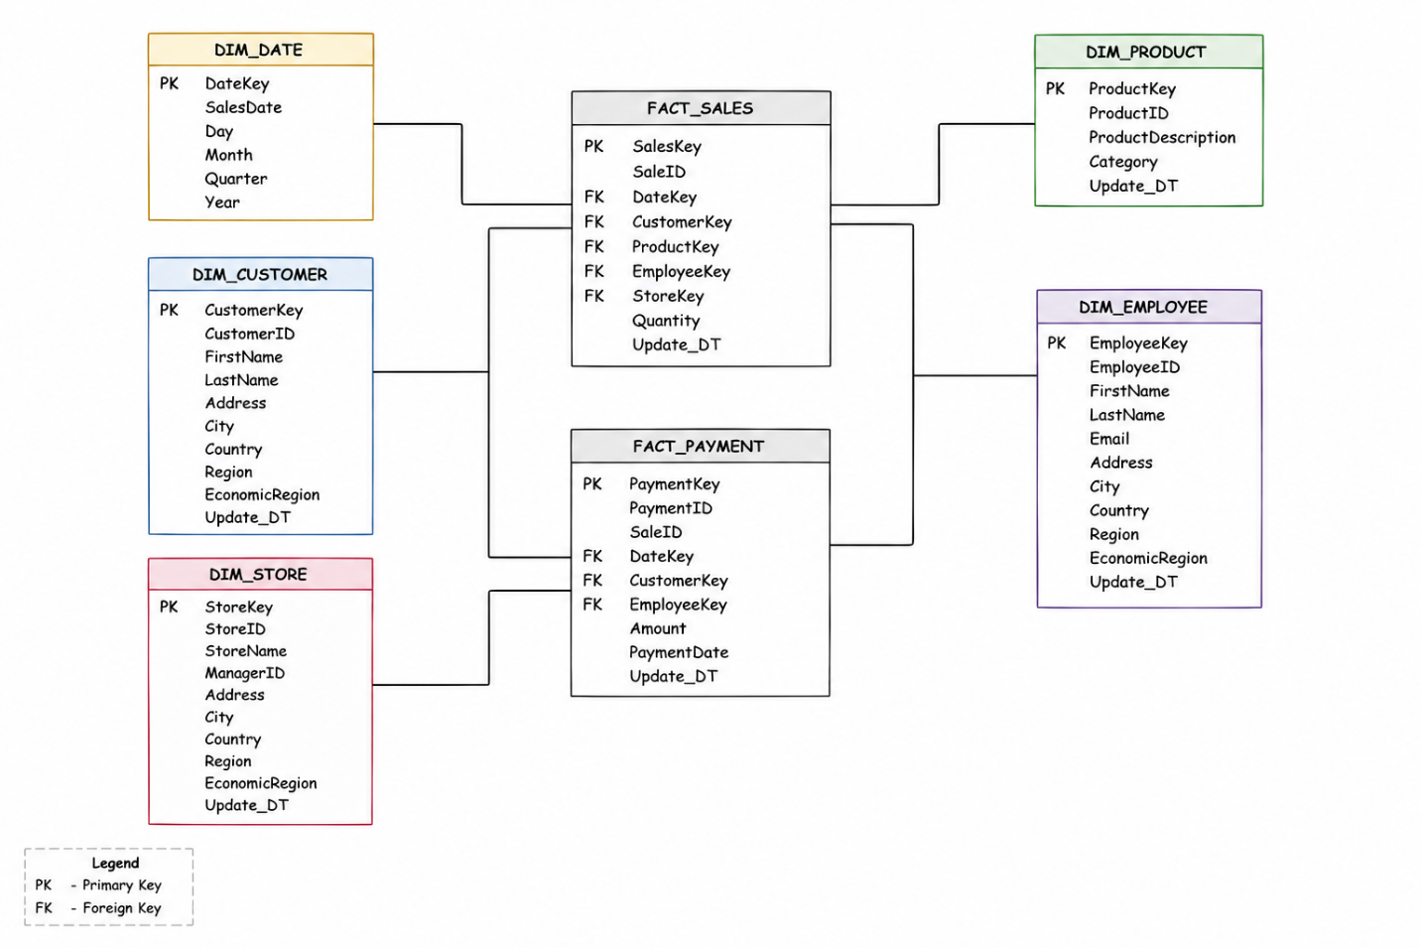

Star Schema – 4-Step Process

Step 1 – Select the Business Process

The selected business processes are Sales and Payments. These represent the main transactional activities in the business model. Sales records capture product purchases, while payment records store information about customer payments. Keeping them as separate fact tables preserves the original business processes.

Step 2 – Declare the Grain
The grain defines what a single row in each fact table represents.
- FactSales: one completed sales transaction of a product to a customer by an employee in a specific store on a specific date.
- FactPayment: one payment made by a customer that is processed by an employee on a specific date.
This grain provides a consistent level of detail for analytical reporting.

Step 3 – Identify the Dimensions
The descriptive information was organized into the following dimensions:
- DimDate – calendar information (SalesDate, Day, Month, Quarter, Year)
- DimCustomer – customer information and location details
- DimProduct – product information, including product category
- DimEmployee – employee information and location details
- DimStore – store information and location details
These dimensions provide the context needed to analyze sales and payment transactions.

Step 4 – Identify the Facts
Two fact tables were created to represent the business events.
- FactSales stores sales transactions and references the Date, Customer, Product, Employee, and Store dimensions.
- FactPayment stores payment transactions and references the Date, Customer, and Employee dimensions together with the payment amount.
The fact tables contain the transactional data, while the dimensions provide descriptive information for reporting and analysis.

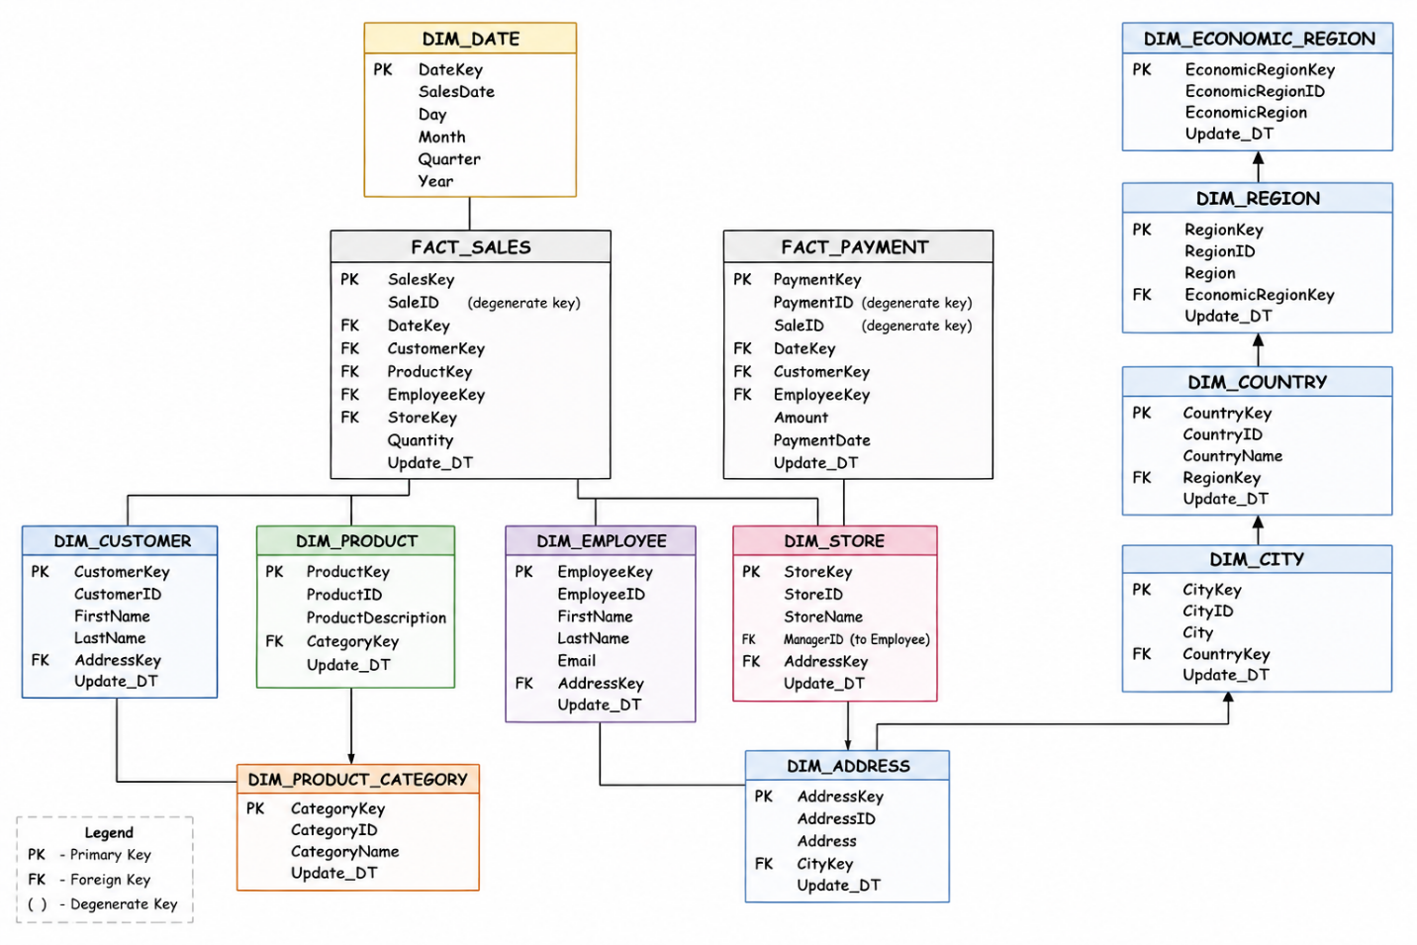

Snowflake Schema – Normalization Steps

Step 1 – Normalize Product Information
The Product Category attributes were separated from the Product dimension into a dedicated DimProductCategory table. The DimProduct table now stores only product-specific information and references the category using a foreign key. This removes duplicated category values and improves data consistency.

Step 2 – Normalize Customer Geography
The geographic attributes were normalized into a shared hierarchy consisting of DimAddress, DimCity, DimCountry, DimRegion, and DimEconomicRegion. Instead of storing address and location details in multiple dimensions, Customer, Employee, and Store reference the same DimAddress table. This eliminates repetitive location data and preserves the original normalized structure.

Step 3 – Separate Business Processes

The original model contains both Sales and Payments as separate business processes. To preserve this structure, two independent fact tables were created: FactSales and FactPayment. Each fact table stores its own transactional data while sharing common dimensions such as Customer, Employee, and Date. This reflects the original business model and avoids combining unrelated transactions.

Step 4 – Preserve the Fact Table
The fact tables remain focused on transactional data and contain only keys and business measures. Normalization was applied only to the dimension tables by extracting hierarchical and reusable information into separate tables. This reduces redundancy, improves data integrity, and produces a Snowflake Schema that closely follows the original 3NF model.

